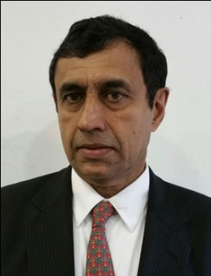
Biography of Mr. Thoranath Sukumaran
M Thoranath Sukumaran(Suku) has over 30 years of banking experience working in some of the major financial centers like New York, London and Mumbai. Most recently Suku was a Senior Vice President at Morgan Stanley in New York. Prior to that he has held senior positions in wealth management and corporate banking in Smith Barney and American Express Bank. He has played active roles in the ADR issue and subsequent M&A transactions for a leading Indian BPO company in the US. He has structured innovative growth funding for Indian companies in sectors as diverse as IT services, Agri- Biotech and Export Import houses. He has also raised sizable funds for Hedge and PE Funds including for Global Real Estate Investing. More recently, as President of Oakwood Strategy Consulting, he has been focusing on “Middle Market” corporations in their efforts to raise growth capital and globalize operations both by organic growth and M&A.

He is active in the Indo US trade associations and was the President of US India American Chamber of Commerce (USIACC), a trade group focusing on the Indo US cross border trade and investment activities of Middle Market companies.

